Practical applications of logical processes

​Two common tools used by developers to help design ​a program's logical flow are flowcharts and pseudocode. ​Let's begin by exploring flowcharts.

Flowchart

​A flowchart is a diagram that represents a process. ​It uses various shapes to show the applications logic ​and arrows to illustrate ​the paths users can take through the software.
​Flowcharts help developers plan ​the logic before writing the code, ​making it easier to understand ​and communicate complex processes. ​Developers often use flowcharts ​to map out the logic of their applications. ​For instance, a developer can ​use a flowchart to represent ​the steps a user can possibly take in a login system. ​For example, suppose we are ​developing an e-commerce checkout process. ​The flowchart would include steps like

1: Selecting products.
2: adding them to the cart.
3: Entering shipping details.
4: Choosing a payment method.
5: Confirming the order.

When a customer selects a payment method, ​there are multiple paths they might take. ​The flowchart makes sure ​all these options are mapped out. ​To build this flowchart, ​the developer can use a tool like Visio or Miro ​to create shapes that represent each step in the flow. ​The shapes represent certain types of events in the flow. ​

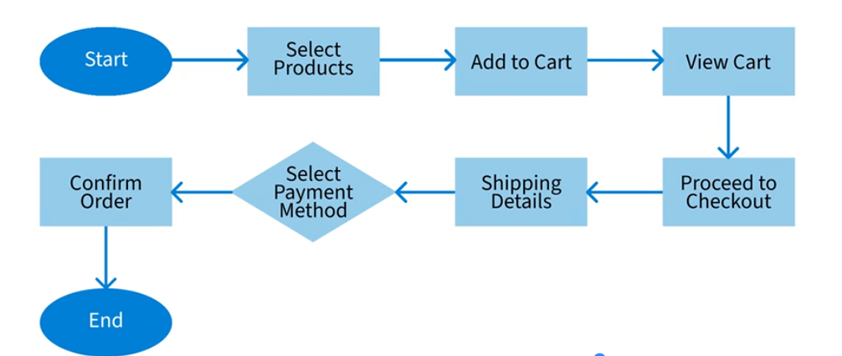

The developer begins by designing ​the e-commerce checkout process ​with the start point using ​an oval shape with the word "Start" in it. The oval clearly marks the beginning of the process, ​signaling to anyone reading the flowchart ​that this is where the customer's journey begins. ​Next, the developer creates the select product step, ​which is represented by ​a rectangular shape containing the words "Select Products". ​The rectangle indicates a process or action step. ​Here, the customer browses through ​the product catalog and selects ​items they want to purchase. ​The developer uses this rectangular shape ​to capture the action of product selection. ​An arrow from the start oval to ​the select products rectangle ​illustrates the direction of the process's flow. ​Following product selection, ​the developer designs the add to ​cart step depicted by ​a rectangle containing the words "Add to Cart".

​The developer chooses the rectangle again to signify ​the simple process action where ​the customer places the ​selected items into the shopping cart, ​a temporary holding area before proceeding to check out. ​The developer adds an arrow that points ​from select products to add to cart. ​The developer then moves to the view cart step, ​using another rectangle, this ​time containing the words "View Cart". ​This shape represents a regular process step ​where the customer reviews the items in their cart, ​checks quantities, and makes ​any necessary adjustments before moving on. ​An arrow is added that points from the ad ​to cart shape to the view cart shape.

​Once the customer is satisfied with the cart, ​the developer sets up the proceed to checkout step, ​marked by a rectangular shape with ​the words "Proceed to Checkout" inside the rectangle. ​This shape indicates the action of transitioning ​from the shopping phase to the purchasing phase. The developer adds an arrow that points from ​the view cart shape to the proceed to checkout shape. ​Next, the developer designs ​the renter shipping detail step, ​which is represented by another rectangle, ​this one containing the words "Shipping Details". ​The rectangle shows this is ​a process step where the customer ​inputs shipping information to ensure correct delivery. ​The arrow points from the proceed to ​checkout shape to the shipping detail shape. ​At this point, the developer introduces ​a decision point, select payment method. ​The developer uses a diamond ​shape here containing the word ​select payment method because it represents ​a decision that leads to multiple paths. ​This shape visually distinguishes ​it from process steps and ​signifies that the customer must ​choose from various payment options, ​such as a credit cart or PayPal.

​The arrow points from the shipping detail shape ​to the select payment method shape. ​At this point, the developer can illustrate ​different payment methods by adding arrows ​and shapes to show each possible method. ​After selecting a payment method, ​the developer adds the confirm order step ​using a rectangle with the words "Confirm Order" added. ​This shape represents the final action step where ​the customer reviews and confirms their order details, ​ensuring everything is correct ​before completing the transaction. ​The arrow points from the select payment method shape ​to the confirm order shape. ​Finally, the developer concludes ​the process with the end, ​using the oval shape containing the word "End". ​The oval marks the completion of the checkout process, ​clearly indicating that ​the customer's journey has reached ​its conclusion and that ​the order has been successfully placed.

​The final arrow points from ​the confirm order shape to the end shape. ​This simple flowchart visually ​illustrates how a user will move through ​the checkout flow and also shows ​the logical order of events the application must support. ​The arrows in their direction can be ​translated into code as logical operators, ​and the flowchart helps ​the developer understand that logical flow.

Pseudocode

​Pseudocode further refines this logical process ​by describing what a piece of code should do. ​Pseudocode is a detailed and readable description ​of what a computer program or algorithm ​must do expressed in ​a natural language rather than in a programming language. ​This helps connect the initial concept ​and the actual code.
​For example, the developer starts designing ​the e-commerce application by ​illustrating the program logic in a flowchart. ​Next, they take the high level design ​and start to translate each of the steps in ​the process into pseudocode ​to get a better idea of what the actual code should do. ​Let's examine a pseudocode example ​using the add products to cart step. ​The code needs to support ​the customer in picking a product. ​The pseudocode will begin with:

Step 1: ​Start function, AddToCart, productID, quantity. ​
Step 2: ​Retrieve the product details from ​the database using productID.
Step 3: ​If product is available in the desired quantity, ​option A, add product and quantity to ​the cart and option B, update the inventory.
​Step 4: ​Confirm addition to the cart.
Step 5 states that if ​the product is not available in the desired quantity, ​then show an error message to the user. ​
Step 6: End function. ​

This pseudocode outlines the steps and conditions in ​a clear and concise way ​ready to be translated into actual code.

